**DOCUMENTATION ON SETTING UP KUBERNETES CLUSTER USING MINIKUBE AND CONFIGURATION OF 3 NODES POSTGRESQL HA CLUSTER**

Prerequisite:

1. Docker is the recommended driver for Minikube.
2. Sufficient resource with at least 2 CPU 2 GB RAM and 20GB free disk space.

Step 1: For Minikube installation on Mac OS, we need to install homebrew before installation of Minikube. See below snapshot.

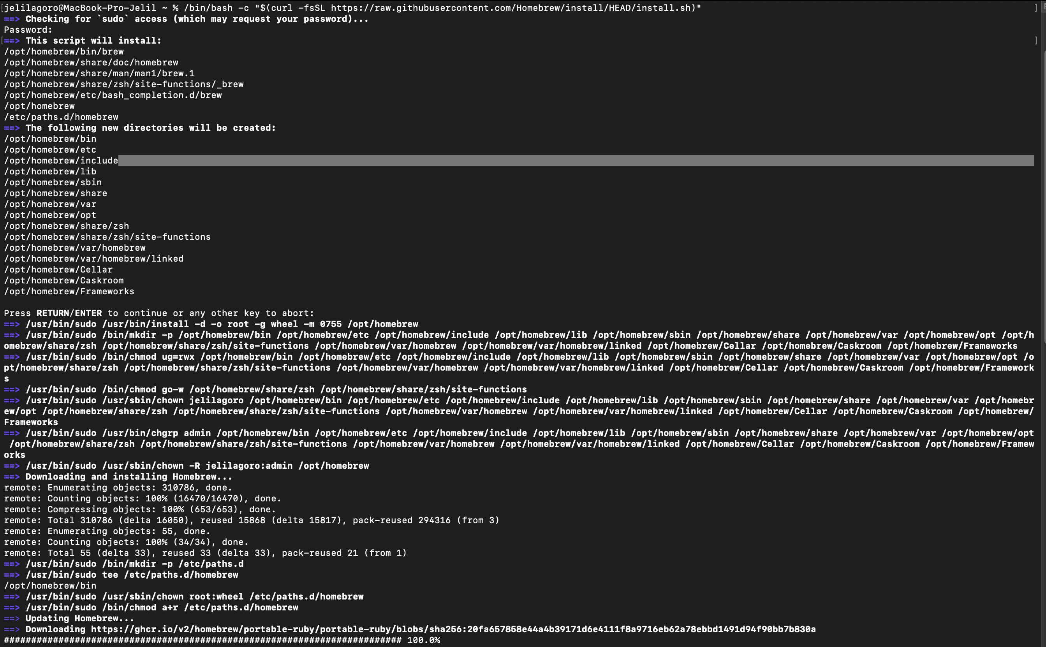

Step2: Install Minikube.

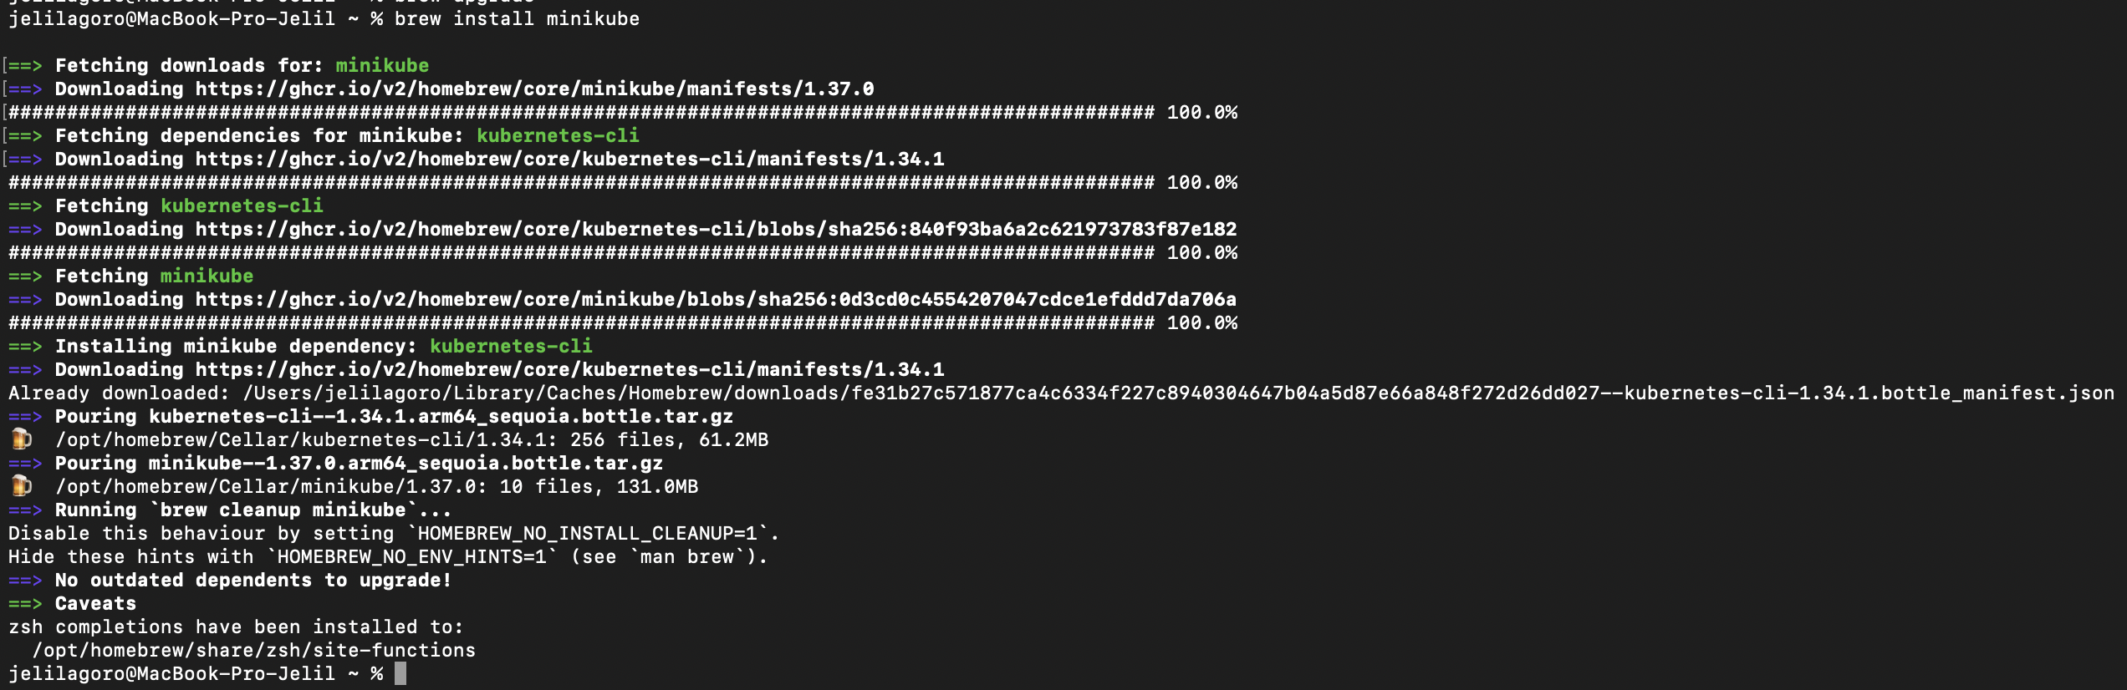

Step 3: Start Minikube.

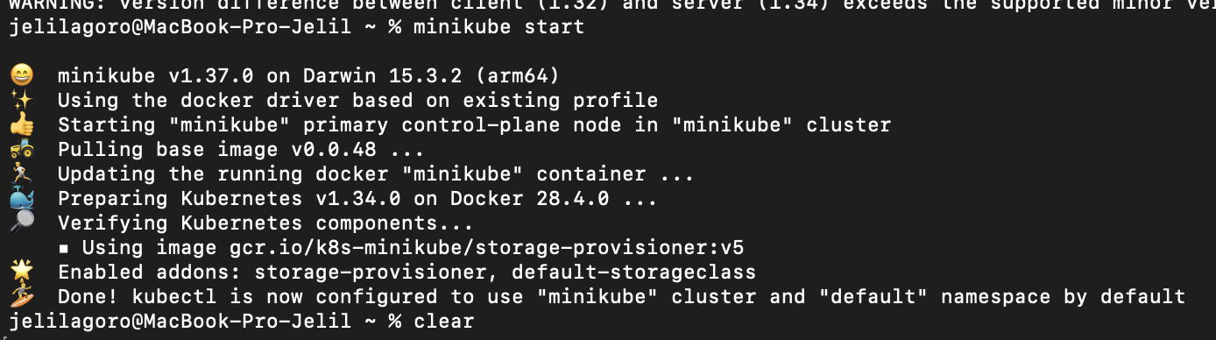

Step 4: Check cluster status.

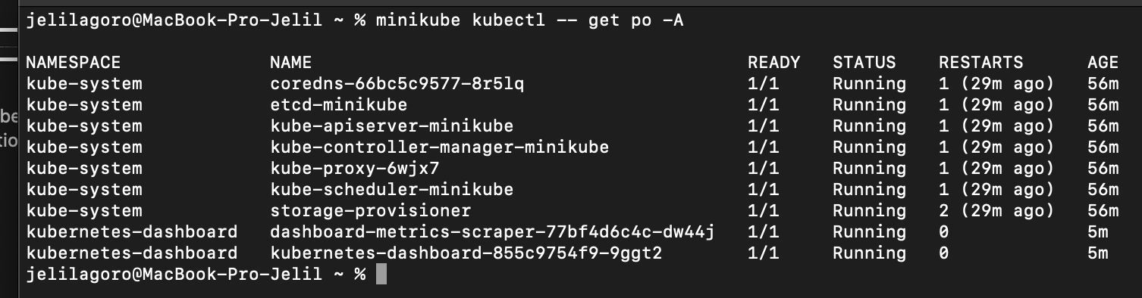

Step 5: Install helm for Kubernetes package manager.

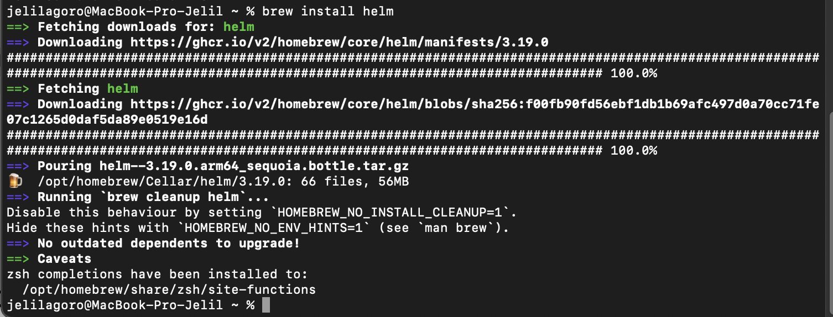

Step 6: Add bitman repository to helm repo.



Step 7: Update helm repository.

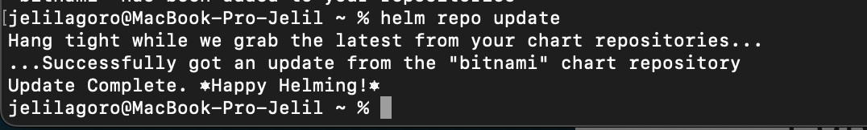

Step 8: Deploy the PostgreSQL HA cluster with 1 Primary and 2 replicas.

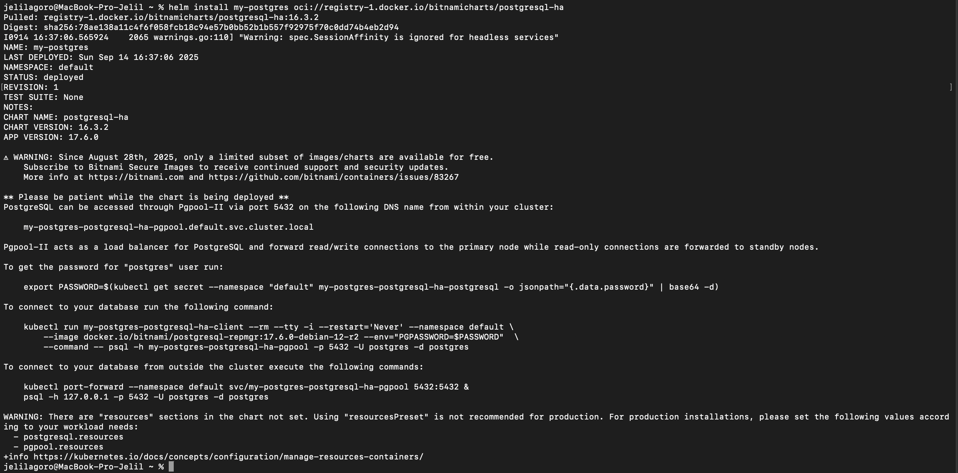

Step 9: Check cluster services.

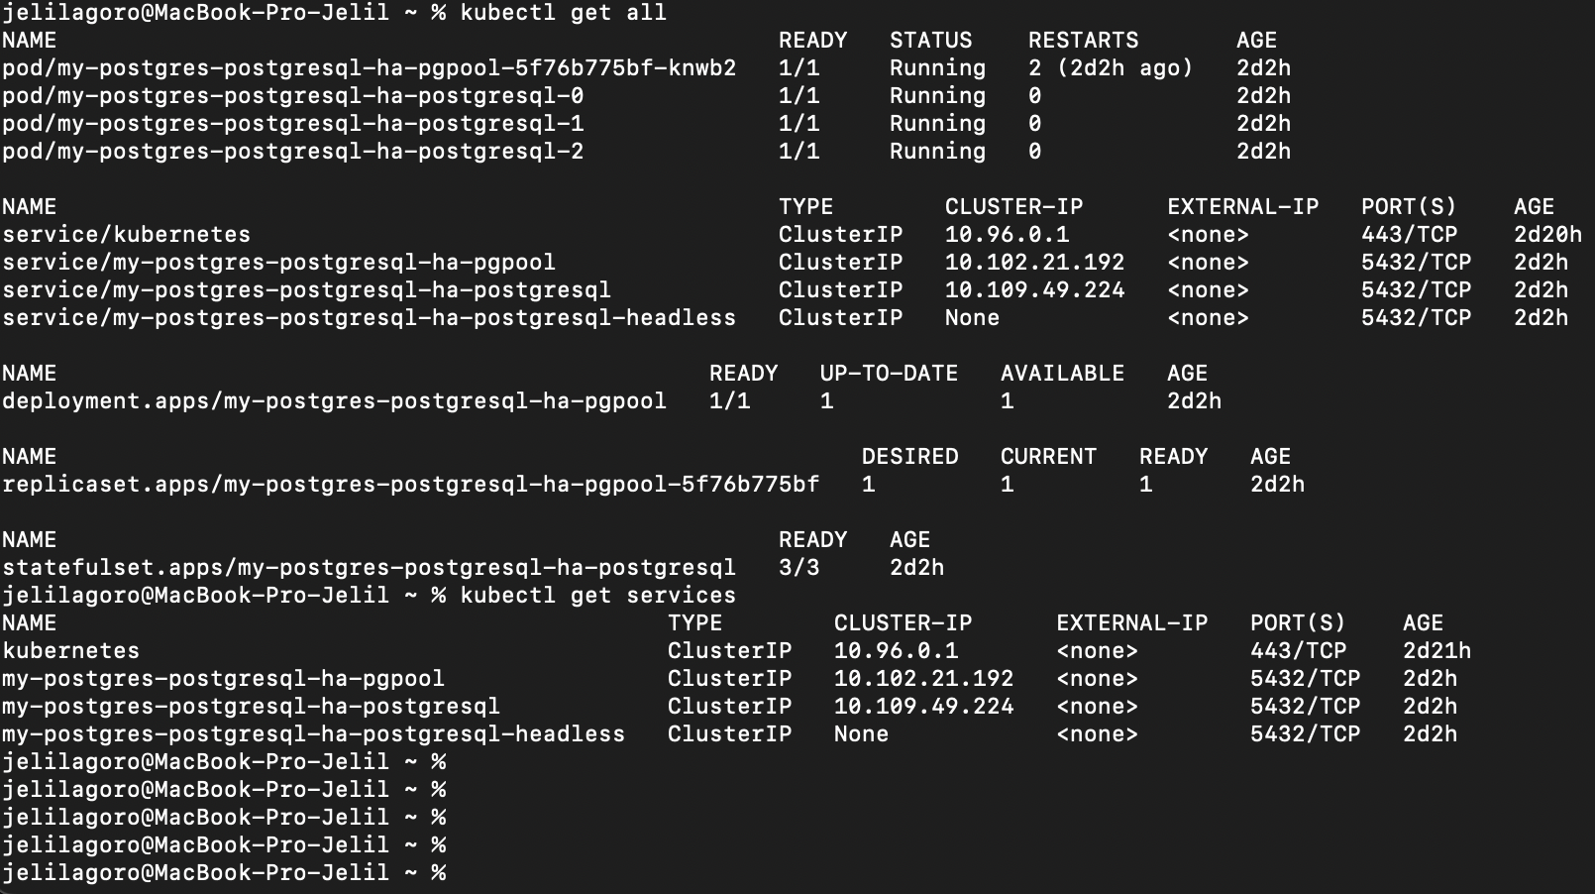

Step 10: Creation of database.

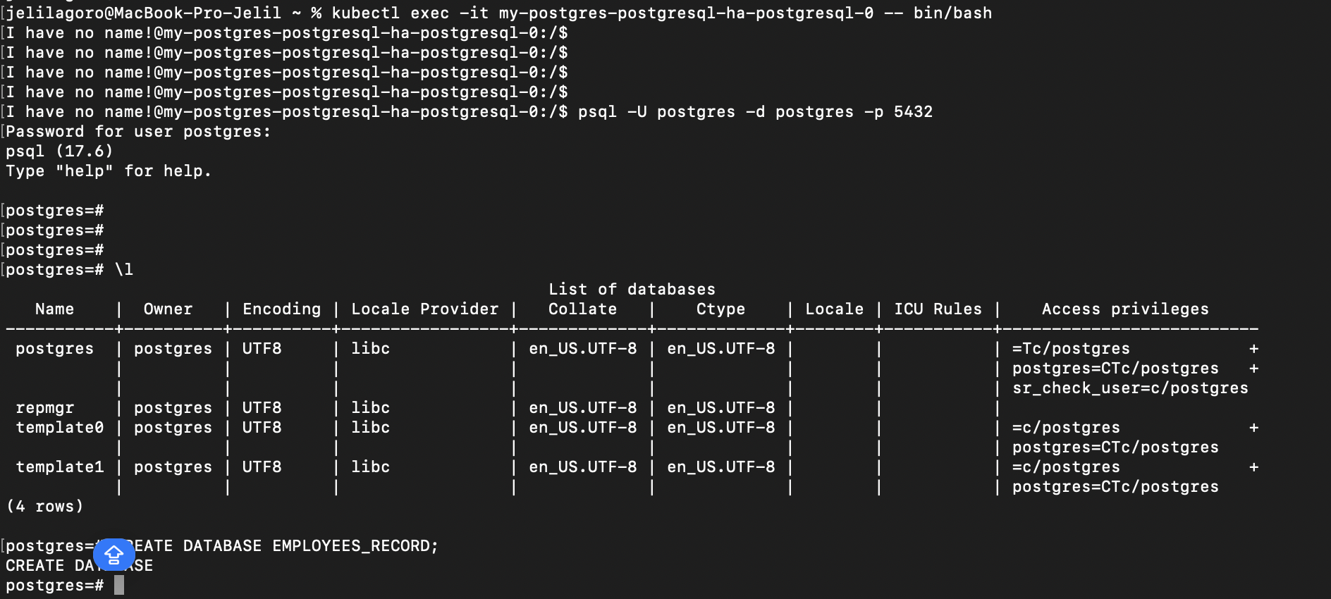

Step 11: Creation of 2 tables on employee_record database.

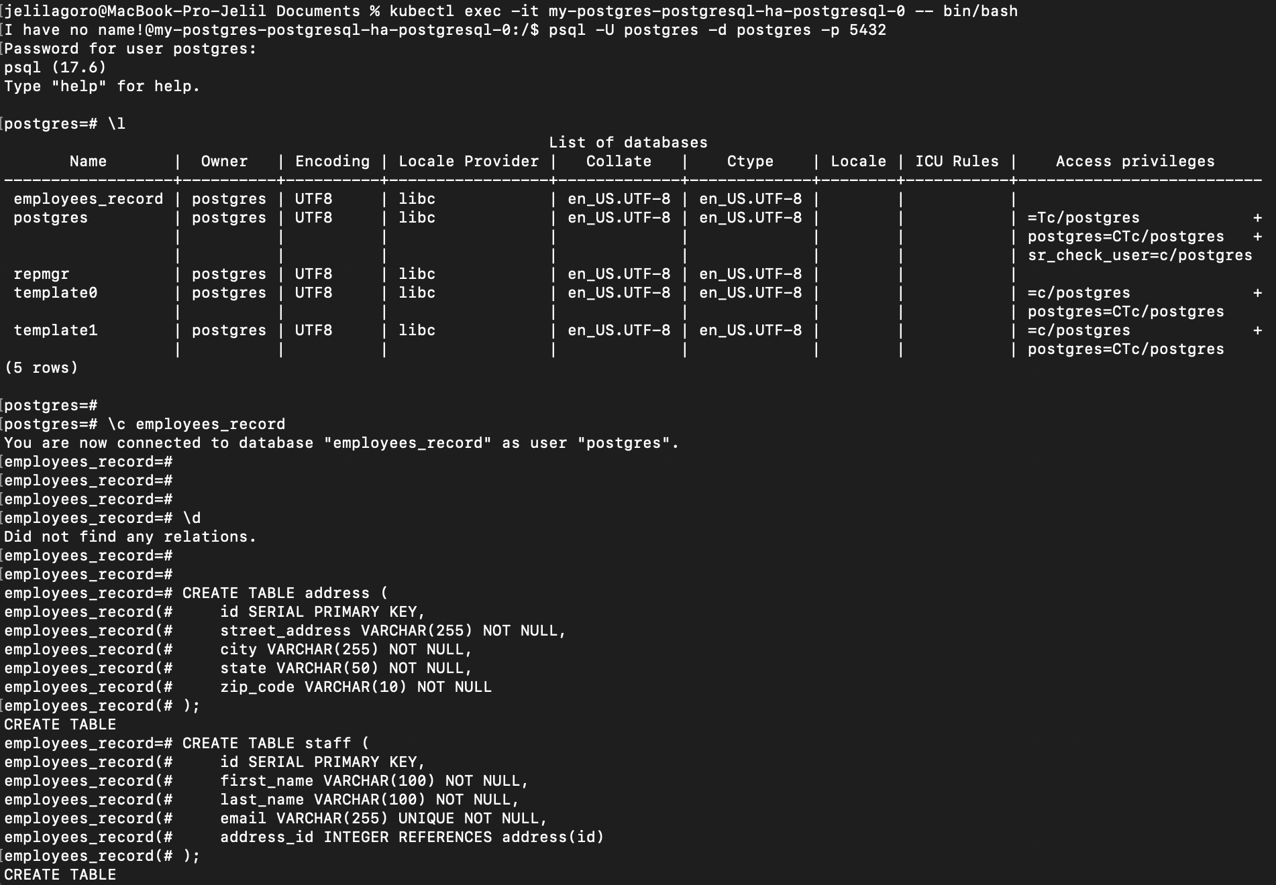

Step 12: Insert records into the 2 tables.

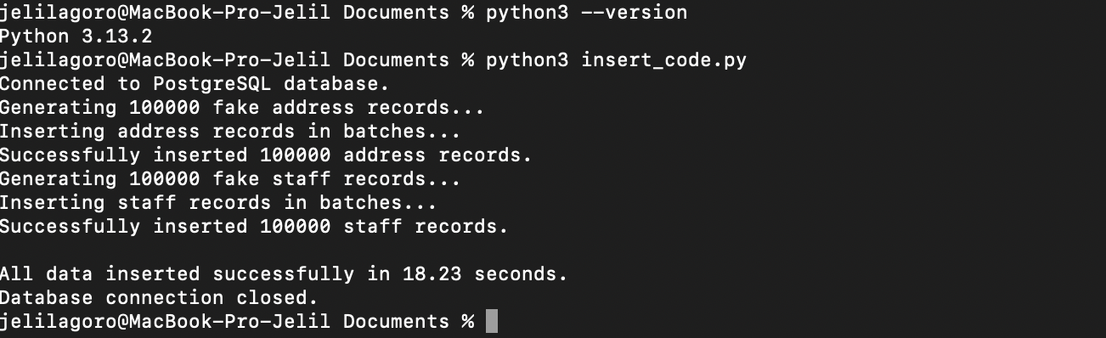

Step 13: Architecture design of the solution.

